Name:
Professor:
Course:
Date:
Biology Lab: Mitosis
- Chromosome: it is a DNA molecule with all hereditary information about an organism.
- Sister chromatid: it is an identical copy of a chromosome formed as a result of DNA replication.
- Centromere: it is a region of the chromosome that attaches to the spindle fiber during alignment of chromosomes along the metaphase plate.
- Diploid: it is a cell containing two sets of chromosomes, each from a parent.
- Haploid: these are cells with half the number of chromosomes.
- G1 – cells increase in size to prepare for DNA synthesis
S – replication of DNA takes place
G2 – cell continues to grow and prepares for the mitosis phase
G0 – the cell stops dividing.
- Mitosis: it is a type of cell division resulting to the formation of two identical daughter cells with equal chromosomes as the parent cell.
- Cytokinesis: it is a process, which involves the division of the cytoplasm of a parent cell to form two daughter cells.
- Meiosis: this is a type of cell division leading to the formation of four daughter cells, each with half the number of chromosomes as the parent cell.
- Recombination/ crossing over: it is the process of exchanging hereditary information between two homologous chromatids (non-sister) during sexual reproduction. This process leads to the formation of recombinant chromosomes.

Mitosis phase | Sketch | Main events
Prophase | 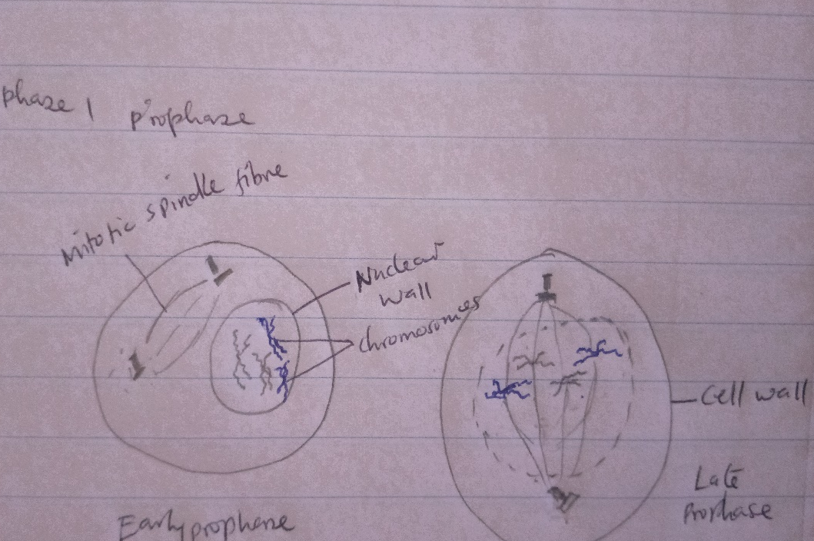 | - Condensation of chromosomes  - Formation of the mitotic spindle  - The nucleus disappears  - Nuclear envelop breaks  - Mitotic spindle is fully formed
Metaphase | 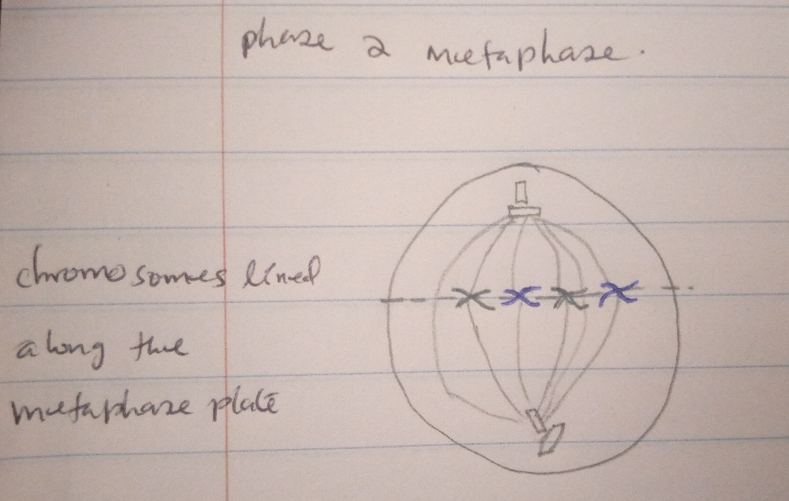 | - Alignment of chromosomes along the metaphase plate  - Chromosomes attached to the poles by the mitotic spindle fiber
anaphase | 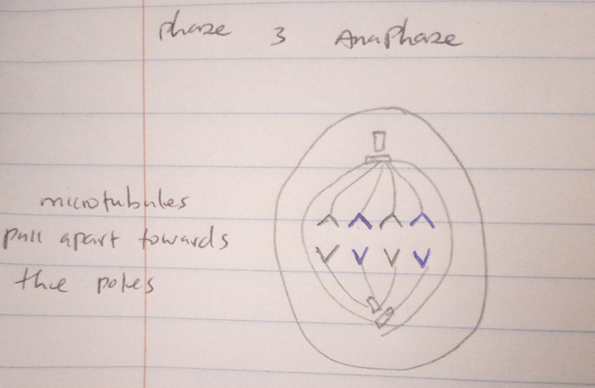 | - Sister chromatids are broken and pulled towards the poles  - Microtubules pull away from each other elongating the cell
Telophase | 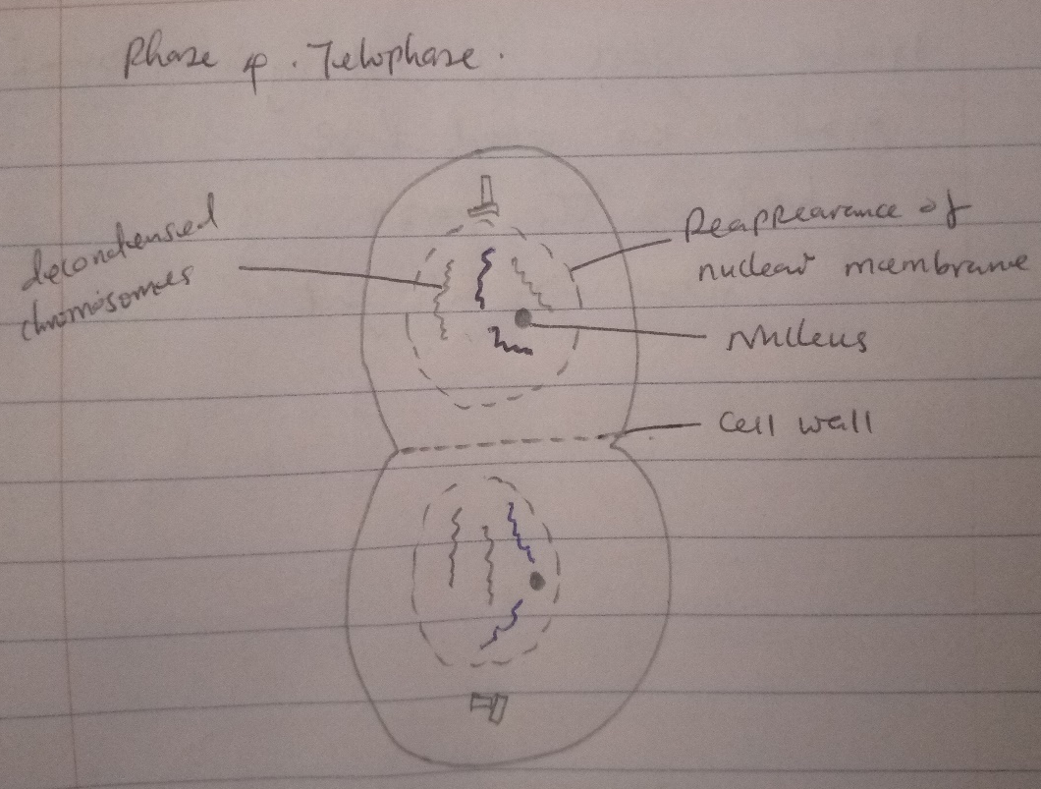 | - Mitotic spindle fiber is broken  - Chromosomes decondense  - Nuclear membrane reappears for the set  - Nucleus reappears for the set

#2. Spindle fibers are structures that help in the division of genetic material in a cell. It ensures that chromosomes are divided equally into identical daughter cells. The spindle fibers originate from the centrosome and are formed by proteins.
#3. The major difference in cytokinesis between plant and animal cells is that in plants, due to rigidity of the cell, a cell wall is developed to divide the cytoplasm into two identical cells. In animal cells, the cell wall is not rigid, allowing the cell to divide by bulging.

